Development and validation of a DIY profiling float for indirect determination of salinity

Caleb Flaim1

[cflaim@uw.edu](mailto:cflaim@uw.edu)

1University of Washington, School of Oceanography

7 December 2023

**Key words:** profiling float, low-cost, salinity

**Running header:** openFloat proposal

**Project summary**

Ocean salinity, a measure of salt concentration in seawater, is a key variable influencing water density and controls important processes like mixing and stratification. Temporal and spatial salinity variability is high in dynamic coastal systems like Puget Sound, which can present a challenge for making salinity measurements that can characterize this variability. Salinity is typically measured using conductivity cells, a sensor that quantifies electrical current through seawater. These sensors can be deployed on ship-based CTDs, spatially-limited moorings, or costly AUVs and can have limited long-term stability. This project, therefore, proposes the development of a cost-efficient DIY profiling float for salinity estimation by way of back-calculation from the TEOS-10 equation of state of seawater. This calculation will be made from known float properties – float density at neutral buoyancy which equals surrounding seawater density – and the in-situ measurement of pressure and temperature via float sensors. This project aims to develop and validate a cost-effective profiling float from common materials with the potential application to increase data resolution in spatially and temporally dynamic estuary systems. For the proof of concept, the float will be deployed alongside a Seaglider in Colvos Passage, WA, for data validation. Unlike many areas of dynamic coastal ecosystems, Colvos Passage experiences high levels of mixing due to local bathymetry and poses as a unique validation site for float development since there is limited spatial variability, making cross-comparison of with the Seaglider easier. This ensures that salinity calculations from the float can be compared to Seaglider data in the same parcel of water to determine the float’s salinity estimation accuracy compared to an industry-standard method for measuring salinity.

**Introduction**

Ocean salinity, a measure of salt concentration in seawater, is a key variable influencing water density and controls important processes, like mixing and stratification. For most of oceanographic history, salinity was determined by taking the ratio of dry salt to evaporated water (e.g., grams of salt per kilogram of evaporated seawater) or though Knudsen titrations (Cox, 1963). These methods require many liters of bottle samples to be analyzed at sea or stored and transported for laboratory analysis. The Knudsen titrations are historically prone to error due to chemical leaching between the samples and the glass storage vessels (Cox, 1963) during transport. More recently, bottle samples to determine high accuracy salinity have been used on cruises (e.g., GO-SHIP), but can be cost inefficient, as they require the use of a ship to collect these measurements. Alternatively, the innovation of salinity sensors that use conductivity – a measure of electrical current though a material – as a proxy for salt concentration in seawater enable the measurement of salt concentration with circuitry. Conductivity can be used as a proxy for salinity since a positive correlation exists between water conductivity and salt concentration (Cox, 1963; Woody et al., 2000).

Initial seawater conductivity sensors were benchtop instruments and could not be used in-situ, requiring bottle samples to be obtained from various depths for ship-board analysis. The advent of waterproofing technologies enabled in-situ conductivity measurements to be made with conductivity cells. In-situ salinity measurements with conductivity cells do not require bottle samples to be obtained regularly, but can be prone to error due to sensor calibration drift over time and biofouling (Woody et al., 2000). Salinity error due to sensor drifting is an important consideration, particularly in the homogeneous deep ocean where high levels of data accuracy are required to differentiate between nearly-identical water parcels. Conductivity cells capable of deep ocean salinity measurements undergo extensive regularly scheduled calibration and are expensive due to their high level of data accuracy. While these sensors are optimal for the deep ocean and environments that experience low variability, this level of accuracy is not needed to quantify variations in dynamic coastal estuarine locations such as Puget Sound, WA, where temporal and spatial variability of salinity is relatively large compared to the open ocean.

Arrays of salinity sensors are better equipped to characterize the spatial and temporal variability of salinity seen in dynamic coastal systems. However, high-cost sensors can be prohibitive in these ecosystems due to the need for high resolution data to accurately describe this variability. Current shipboard and robotic salinity sampling techniques obtain high accuracy data, but are limited in that they cannot be deployed broadly to encompass a high-variability regions like Puget Sound due to cost. This study aims to develop a low-cost DIY profiling float capable of salinity estimation to address this need. The goal is for the float to be inexpensively reproduced to increase the spatial resolution of observations needed to characterize such dynamic systems. This study proposes that a buoyancy driven float can indirectly determine salinity through back-calculation of the TEOS-10 equation of state (McDougall et al., 2012) by inexpensively measuring temperature and pressure along with known properties of the float (e.g., density at neutral buoyancy). Buoyancy-driven ocean observing platforms like Argo floats and Seagliders control their volume to achieve neutral buoyancy, where vehicle density equals seawater density, enabling them to maintain position at a given depth. The proposed float’s salinity measurements will be cross-validated against those made by a Seaglider – an industry-grade buoyancy-driven autonomous underwater vehicle (AUV) that glides through seawater, much like an airplane through air, to collect water column profiles – via its conductivity cell. This conductivity cell is calibrated against known standards during regular service by its manufacturer, Seabird Electronics. Cross-validation of field data will occur during deployment in Colvos Passage, the western side of Vashon Island, WA (Figure 1a).

This location experiences high levels of turbulent mixing due to sills – thin areas of rapidly reduced depth – in the local bathymetry (Seim and Gregg, 1997; Ovall, 2019). Flood tides bring water into Southern Puget Sound through East Passage (the eastern edge of Vashon Island) where it is then upwelled and mixed over a sill in the Tacoma Narrows; the ebb tide then again pulls water through the Tacoma Narrows and into Colvos Passage (Seim and Gregg, 1997; Ovall, 2019). As water flows over a sill, its velocity increases and pressure therefore decreases in adherence to Bernoulli’s principle (Seim and Gregg, 1997). Dense water near a sill’s base is drawn upward as pressure over the sill decreases and is then turbulently mixed with the less-dense waters passing over (Seim and Gregg, 1997). Flow in Colvos Passage is always directed in the northward direction (Ovall, 2019), making it an ideal place to be able to predict the trajectory of the float and ensure it can be co-located with the Seaglider. The high levels of mixing around Colvos Passage cause spatial variability of salinity to be low. This increases confidence that the proposed float and Seaglider will measure similar water masses when deployed in the same vicinity, enabling easy field cross-comparisons.

b)

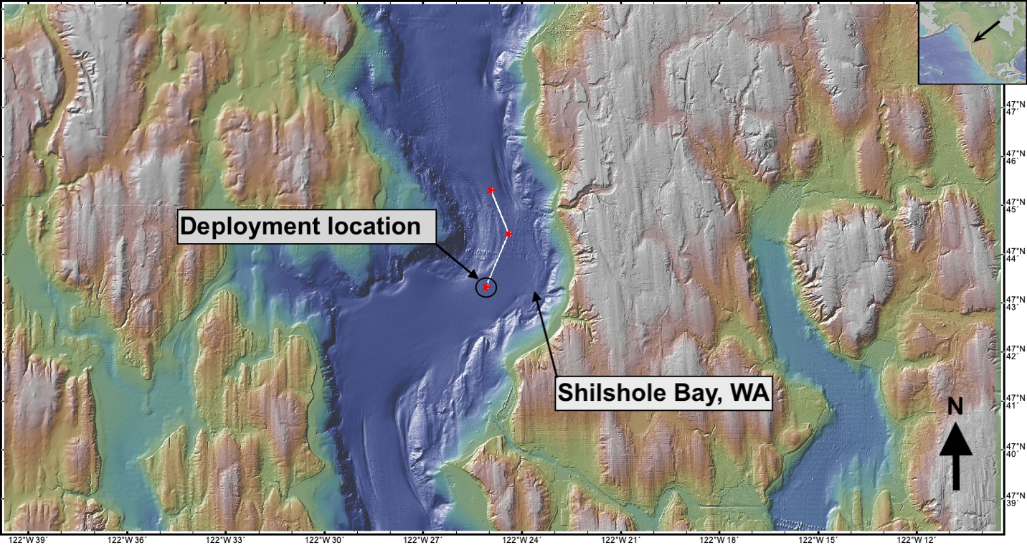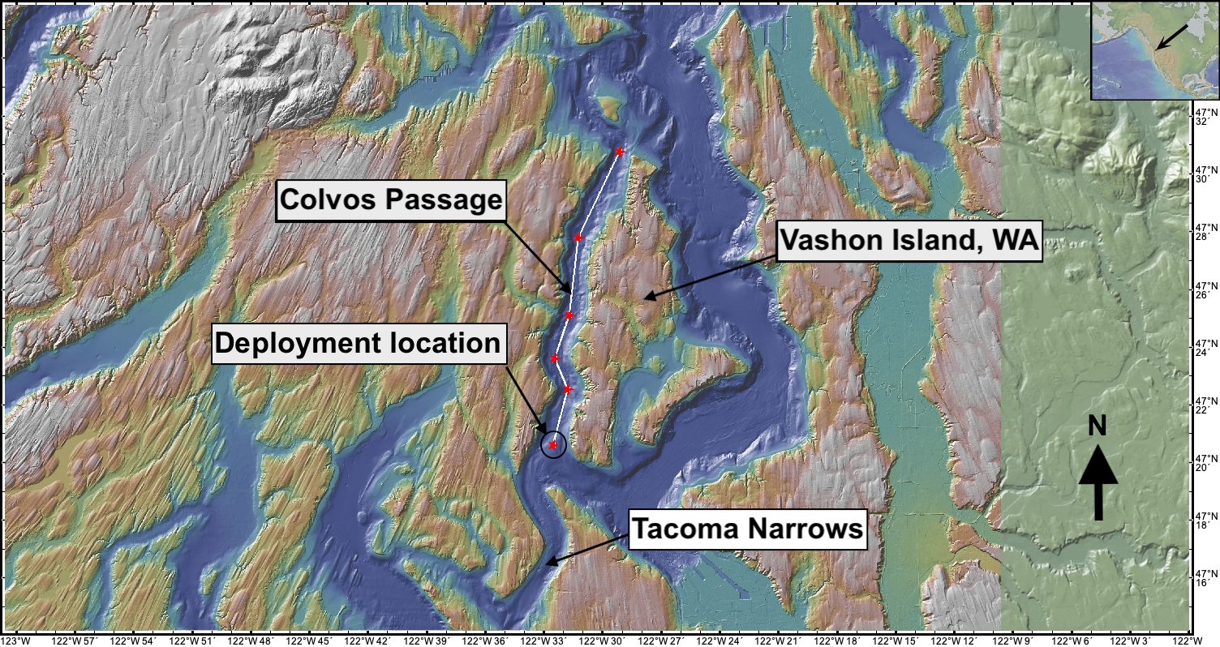

a)

**Figure 1** Panel a) shows the deployment location and planned track of SeaGlider 195 in Colvos Passage on the West side of Vashon Island. The DIY float will be deployed alongside the SeaGlider and allowed to drift down the passage while making continuous profiles. Red stars indicate planned SeaGlider and float dive sights or pickup locations. White lines represent the likely path of the SeaGlider or float once deployed. The red star circumscribed by a black circle indicates likely deployment locations. Actual deployment locations may vary depending on local boat traffic and tidal patterns. Panel b) shows the deployment location and planned track of SeaGlider 175 near Shilshole Bay, WA. Manual casts of the DIY float tethered to a line will be done at every SeaGlider dive sight to collect profile data.

**Proposed research**

1. **Building the openFloat**

This project proposes the design and build of an open-source autonomous profiling float – dubbed openFloat – for the collection of foundational oceanographic data variables such as temperature, pressure, and salinity (estimated). The openFloat will use readily available electronics modules to collect, store, and transmit data. The float will collect 12-bit analog temperature, GPS, time, light intensity, acceleration and absolute positioning, internal pressure, internal humidity, and internal temperature. These data will be stored on an internal 4GB SD card and later transmitted by LoRa (long-range) radio via the 915 MHz industrial, scientific, and medical band to a remote storage device shoreside or onboard the research vessel. This project hypothesizes an inexpensive DIY profiling float can be developed and used for salinity estimation by way of back-calculation from the TEOS-10 equation of state of seawater through known float properties – density at neutral buoyancy, which equal the density of the surrounding water mass – and the in-situ measurement of pressure and temperature.

The float will be controlled by an Adafruit ESP32 Feather Huzzah, a microcontroller board that can be purchased for 20 USD or less. This board has processor speeds of up to 240 MHz (Adafruit Industries, 2023), a speed roughly 10 times as fast as the TT8 processor on the original SeaGliders (Freescale Semiconductor, 1995; Eriksen et al., 2001), and runs on 3.3 V logic. The ESP32 used in the development of the openFloat has 8 MB Flash memory, 2 MB PSRAM, built-in Bluetooth and Wi-Fi capabilities, and 21 available pins for signal input/output (see <https://learn.adafruit.com/adafruit-esp32-feather-v2/overview> for further detail). Furthermore, the ESP32 is capable of sub-milliamp deep sleep with a nominal current draw of 70 *µ*A. The fast processor speeds, large quantity of input-output pins, 12-bit analog pins, and low current draw of the ESP32 yields an opportunity for high precision and low-power data collection. The ESP32 will be used to read values from the temperature, pressure, and lux modules and later transmit the data to shore (see Figure 2 for a preliminary wiring diagram and find more detailed information at <https://github.com/cflaim1123/openFloat>).

The openFloat will propel itself vertically through the water column by changing its density via a buoyancy engine (Figure 3) built from common 3D printer motor control circuitry (e.g., Nema17 stepper motors and TMC2209 stepper motor drivers). This engine is an electrically driven mechanism used to increase or decrease the float’s volume while its mass is held constant; this causes the openFloat’s density to change relative to the surrounding water. The buoyancy engine will use an electric motor to linearly move a piston head though an oil filled tube to inflate or deflate a rubber bladder. As the rubber bladder inflates with oil, the float experiences positive buoyancy and will begin to rise; as the rubber bladder deflate with oil, the float experiences negative buoyancy and will begin to sink. The buoyancy engine will enable the float to achieve a six-percent volume change when ballasted to be neutrally buoyant.

**Figure 2** Preliminary wiring diagram for the data collection and environmental sensing electronics of openFloat. The top of the board, from left to right, shows the GPS antenna, LoRa antenna, analog temperature sensor, digital temperature sensor, and lux sensor. Generally, red and black wires represent power and ground lines; green and white wires represent I2C communication lines; golden-rod and maroon wires represent analog data signals. The remaining colored wires serve various activation functions.

(1)

(2)

(3)

(4)

(5)

(6)

(7)

(8)

(9)

**Figure 3** The buoyancy engine is mounted at the bottom of the float and is comprised of the piston and housing components. The piston is made from 3D-printed couplers (4 and 8), 0.5-inch PVC pipe (6), and a machined aluminum piston head (9). The piston is moved through the outer 1-inch PVC pipe housing (5) via a brass TR8x2 ACME a traveling nut (4) and lead screw (7). The lead screw is turned by a stepper motor (1) mounted to the outer 1-inch housing via 3D-printed mounts (2). The threaded rod is fixed to the motor shaft with a 3D-printed a coupler (3). As the piston is moved through the outer housing by way of the motor rotating the lead screw, white mineral oil will be displaced, causing a rubber balloon to inflate or deflate. The stepper motor will be controlled with an ESP32 microcontroller and TMC2209 stepper motor controller. All 3D-printed parts are solid and made of PETG plastic.

1. **Testing and calibrating the openFloat**

Once assembled, the openFloat will undergo calibration and in-water testing. The openFloat will perform tests in a four-meter-deep saltwater test tank to confirm functionality of its buoyancy system and waterproofness. Base-line calibrations of the float’s sensors and salinity estimation against a co-deployed calibrated SBE37 CTD and Seaglider will be performed during each tank test. Onboard temperature sensors will additionally undergo dunk tests to measure their response time – the length of time required for heat energy to diffuse across the sensor housing – to better contextualize environmental temperature readings and determine necessary float vertical velocity. Dunk tests involve quickly moving the temperature sensors from a fluid of one temperature to a fluid of different temperature (e.g., moving the probe from room-temperature water to 40 °C water).

While in the test pool, the openFloat will take rapid replicate measurements to assess the accuracy and precision of its salinity estimation relative to recently calibrated industry-grade sensors; these will serve as the known values. Accuracy and precision for the openFloat will be calculated using the mean and standard deviation of the repeated measurements relative to the known values. The accuracy of the salinity estimation will be limited by the least accurate measurement used in the salinity calculation. The DS18B20 temperature probes used by the openFloat have an accuracy of ±0.1 °C and the intended pressure sensor has an accuracy of ± 20 mbar (Lymen et al., 2020, Lauer et al., 2023). The openFloat itself will serve as a density sensor by measuring its density when it is neutrally buoyant relative to the water around it. When this happens, the density of the float is equal to the density of the surrounding water. The accuracy of the float’s density measurement will be limited by its mass, as the volume is determined by Onshape, an online CAD program, and is accurate to ±0.001 cm3. The mass is only known to ±0.1 g. In this phase, the accuracy of the salinity measurement will be calculated to determine the utility of this salinity measurement method.

During the first deployment, the float will be tethered to a line and manually lowered over the side of the boat at ~0.1 m s-1 in Shilshole Bay (Figure 1b) to approximate the depth profiles collected by SeaGlider 175 (Frajka-Williams et al., 2011). This serves as an initial comparison of the openFloat and SeaGlider’s sensor data in an environmental context and allows for preliminary salinity estimations. The openFloatwill collect profile data in Colvos Passage, WA, (Figure 1b) by autonomously moving vertically through the water column via its buoyancy engine during the second deployment. The second deployment serves as the validation experiment.

1. **Field implementation and data analysis**

The openFloat will be deployed in Colvos Passage in conjunction with SeaGlider 195 to determine how well it can indirectly estimate salinity. Colvos Passage is a narrow channel along the western edge of Vashon Island, WA (Figure 1b). This location experiences high levels of turbulent mixing due to local bathymetry. The presence of high mixing in and around Colvos Passage causes the water masses in the channel to be semi-homogeneous. Therefore, Colvos Passage as a unique location to ground-truth the openFloat’s salinity estimation since spatial variability is minimal. It is crucial for the openFloat and SeaGlider 195 to collect data in nearly identical water masses to directly compare the openFloat’s salinity estimation to an industry-grade measurement. Minimizing the spatial variability of the openFloat’s ground-truthing deployment location reduces environmental sources of error and ensures that errors seen in the estimated salinity data are due to its derivation.

Salinity values will be estimated by way of back-calculation using the TEOS-10 equation of state of seawater. The Gibbs SeaWater (GSW) Oceanographic Toolbox of TEOS-10, a downloadable MATLAB package (see <https://www.teos-10.org/pubs/gsw/html/gsw_contents.html#16>), has native functions to solve for given variables of the TEOS-10 equation of state (Feistel, 2003). The function gsw_SA_from_rho_t_exact calculates absolute salinity when given water density, in-situ temperature, and pressure. The openFloat will measure temperature and pressure directly, and measure water density indirectly by achieving neutral buoyancy and reporting float density therefore achieving all the required known variables to calculate salinity using this function.

The openFloat directly measures in-situ temperature and pressure via onboard sensors. The float itself serves as a density sensor since its mass and volume (used to calculate density, where density equals mass divided by volume) will be known at any time. The mass of the float will remain constant during a deployment and volume can be precisely calculated from the displacement of the buoyancy engine:

$${∆V}_{f}={∆z}_{p}*A_{p}+V_{b}$$

where *∆Vf*  is the change in float volume, *∆zp* is thevertical displacement of the buoyancy engine piston head, *Ap* is the cross-sectional area of the piston head, and *Vb* is the base-volume of the float when it is neutrally buoyant. The float will be neutrally buoyant when the time rate of change of pressure (the vertical velocity) is near zero and vertical acceleration cycles between two constant values (i.e., the float is bobbing on a density surface). This can be described by:

eq 1

$ρ_{w}=ρ_{f} when \left(\frac{dP}{dt}\sim 0\right)∧(-j≤\frac{dP^{2}}{d^{2}t}≤j)$

where $ρ_{w}$ is water parcel density, $ρ_{f}$ is density of the float, $\frac{dP}{dt}$ is vertical velocity, $\frac{dP^{2}}{d^{2}t}$ is vertical acceleration, *t* is time, and *j* is an empirically determined value. When these criteria are met, and the floats density is known, the surrounding water parcel will be of a known temperature, pressure, and density. The openFloat’s density will be calculated by dividing its mass by its calculated volume. These known parameters allow salinity to be calculated using the following MATLAB code:

eq 2

SA = gsw_SA_from_rho_t_exact(rho, T, p)

where SA is absolute salinity, rho is water density, T is in-situ temperature, and p is pressure. For example, if the float is neutrally buoyant at a density of 1018 kg m-3, measures a temperature of 15 °C, and pressure of 100 dbar, an absolute salinity of SA = 24.1593 g kg-1 is calculated for the water parcel.

**Proposed timeline and budget**

**Timeline**

This project will occur in three main stages: the float development, data analysis, and manuscript writing stages (see <https://github.com/cflaim1123/openFloat/blob/main/proposal/timelines/flaimThesisTimelineFull.pdf> for the full project timeline). The float development stage is to occur from 27 September 2023 to 15 December 2023, the duration of the autumn offering of Ocean 443 (Table 1). This stage begins with the building and programming of the float’s electrical systems that do not pertain to the buoyancy engine. After the float’s data collection electronics are operable, the float will be deployed in the main basin of Puget Sound, WA, near Shilshole Bay Marina (Figure 1b) alongside a SeaGlider for an initial validation of the system’s data collection and pressure casing. During this deployment, the float will be tethered to a line and lowered to ~75 m to simulate a dive/surface sequence; we aim for the float to sink and rise at ~0.1m s-1 to match the average speed of a SeaGlider flying through water (Eriksen et al., 2001; Frajka-Williams et al., 2011). A manual cast of the float to this depth will take ~25 minutes in total and be performed every time the SeaGlider surfaces near the boat. This deployment will take six to eight hours. Once the initial test deployment is finished, the design and build of the buoyancy engine will take place.

**Table1** Project timeline for the openFloat build and deployment.

|  |  |  |  |
| --- | --- | --- | --- |
| **Project stage** | **Subsection** | **Start date** | **End date** |
| Float development | Concept development | 9/25/2023 | 10/04/2024 |
| Find and order parts | 9/25/2023 | 10/10/2023 |
| Background research | 10/02/2023 | 10/29/2023 |
| Electronics design | 10/09/2023 | 10/21/2023 |
| Electronics build | 10/20/2023 | 11/01/2023 |
| General programming | 10/30/2023 | 11/08/2023 |
| Float testing and deployment without profiling capability near Shilshole | 11/06/2023 | 11/10/2023 |
| Buoyancy engine build | 10/23/2023 | 11/03/2023 |
| Buoyancy engine build | 11/04/2023 | 11/20/2023 |
| Float assembly | 11/20/2023 | 11/26/2023 |
| Final float testing and deployment in Colvos Passage. | 11/27/2023 | 12/05/2023 |
| Data analysis | Produce desired plots to compare float data to SeaGlider data | 1/03/2024 | 1/11/2024 |
| Produce salinity transects of Colvos Passage | 1/11/2024 | 1/15/2024 |
| Produce engineering plots to asses float’s performance | 1/12/2024 | 1/16/2024 |
| Paper writing | Follow Ocean 444 assignment deadlines | 1/03/2024 | 3/12/2024 |

The buoyancy engine will then be integrated with the float’s existing electrical systems and programmed to change volume given certain pressure, humidity, or acceleration signals. Finally, the float will be deployed in Colvos Passage, WA (Figure 1b) alongside a SeaGlider for data collection and comparison. This deployment will last approximately 12-hours. The proceeding two stages will occur during the winter 2024 academic quarter and largely follow the timeline of the Ocean 444 course.

**Table 2** openFloat project budget.

|  |  |  |  |  |
| --- | --- | --- | --- | --- |
| **Category** | **Item** | **#** | **Price per** | **Total price** |
| Electrical - general | perfboard (pack of 50) | 7 | $0.50 | $3.50 |
| Misc wires | NA | NA | $15.00 |
| Male header pins | NA | NA | $5.00 |
| Female header pins | NA | NA | $5.00 |
| Solder | NA | NA | $10.00 |
| Resistors | NA | NA | $0.10 |
| Misc GPS radio wires | NA | NA | $15.00 |
| Electrical - control | ESP32 feather huzzah v2 | 2 | $19.95 | $39.90 |
| BLDC motor | 1 | $30.00 | $30.00 |
| 5V, 5A voltage step-down regulator | 1 | $32.95 | $32.95 |
| custom battery pack | 1 | $15.00 | $15.00 |
| |  | | --- | | Electrical - sensing | |  | |  | |  | |  | |  | |  | |  | |  | |  | |  | | analog pressure sensor | 1 | $20.00 | $20.00 |
| Thermistor | 1 | $2.00 | $2.00 |
| adafruit data logger feather wing | 1 | $8.95 | $8.95 |
| digital temperature sensor (pack of 5) | 1 | $10.00 | $10.00 |
| BMP180 pressure sensor | 1 | $9.95 | $9.95 |
| DHT22 humidity sensor | 1 | $9.95 | $9.95 |
| TSL2591 lux sensor | 1 | $6.95 | $6.95 |
| Adafruit 9-DOF absolute orientation IMU - BN055 | 1 | $35.00 | $35.00 |
| Adafruit ultiamte GPS | 2 | $30.00 | $60.00 |
| 915 mHz LoRa radio module | 2 | $20.00 | $40.00 |
| Precision current meter | 1 | $10.00 | $10.00 |
| GPS antenna | 1 | $20.00 | $20.00 |
| Radio antenna | 2 | $10.00 | $20.00 |
| |  | | --- | | Mechanical | |  | |  | | Low-pitch, high-precision ACME lead screw | 1 | $15.00 | $15.00 |
| Misc O-ring | NA | NA | $10.00 |
| Misc PVC pipe for piston | 1 | $10.00 | $10.00 |
| 4" PVC pipe | 1 | $20.00 | $20.00 |
| 4" PVC endcaps | 2 | $10.00 | $20.00 |
| metal cable glands | 5 | $10.00 | $50.00 |
| Epoxy | 2 | $10.00 | $20.00 |
|  | | | Total: | $529.25 |

**Budget**

This project aims to build a DIY profiling float in under 500 USD (see <https://github.com/cflaim1123/openFloat/blob/main/proposal/budget/openFloatBudget.pdf> for the full budget). Funding for this project will come from the University of Washington Ocean Technology Center’s project budget. Table 2 details the overall expenditure for the project to build to float from scratch – no parts were previously possessed. The electrical-sensing category is the largest expense for the openFloat project, followed by the Mechanical, Electrical-control, and Electrical-general categories. The total cost of building this float is ~530 USD, however, half of the price of materials are already possessed by the Ocean Technology Center. Approximately 260 USD of materials remain to be purchased. These cost estimates do not include compensation for the labor of designing, assembling, or testing the float.

**References**

Adafruit Industries. (2023, 10, 26). Adafruit ESP32 Feather V2. <https://cdn-learn.adafruit.com/downloads/pdf/adafruit-esp32-feather-v2.pdf>.

Bretschneider, D. E., Cannon, G. A., Holbrook, J. R., & Pashinski, D. J. (1985). Variability of subtidal current structure in a fjord estuary: Puget Sound, Washington. Journal of Geophysical Research: Oceans, 90(C6), 11949–11958. <https://doi.org/10.1029/JC090iC06p11949>.

Assendelft, R. S., & van Meerveld, H. J. I. (2019). A Low-Cost, Multi-Sensor System to Monitor Temporary Stream Dynamics in Mountainous Headwater Catchments. Sensors (Basel, Switzerland), 19(21), 4645–. https://doi.org/10.3390/s19214645

Cox, R. A. (1963). The salinity problem. Progress in Oceanography, 1, 243–261. <https://doi.org/10.1016/0079-6611(63)90006-5>.

Eriksen, C. C., Osse, T. J., Light, R. D., Wen, T., Lehman, T. W., Sabin, P. L., Ballard, J. W., & Chiodi, A. M. (2001). SeaGlider: a long-range autonomous underwater vehicle for oceanographic research. IEEE Journal of Oceanic Engineering, 26(4), 424–436. <https://doi.org/10.1109/48.972073>.

Frajka-Williams, E., Eriksen, C. C., Rhines, P. B., & Harcourt, R. R. (2011). Determining Vertical Water Velocities from SeaGlider. Journal of Atmospheric and Oceanic Technology, 28(12), 1641–1656. <https://doi.org/10.1175/2011JTECHO830.1>.

Feistel, R. (2003). A new extended Gibbs thermodynamic potential of seawater. Progress in Oceanography, 58(1), 43–114. <https://doi.org/10.1016/S0079-6611(03)00088-0>.

Freescale Semiconductor, Inc. (1995). M68300 Family MC68332 User’s Manual. <https://docs.rs-online.com/b7af/0900766b806a28f4.pdf>.

Gould, J., Roemmich, D., Wijffels, S., Freeland, H., Ignaszewsky, M., Jianping, X., Pouliquen, S., Desaubies, Y., Send, U., Radhakrishnan, K., Takeuchi, K., Kim, K., Danchenkov, M., Sutton, P., King, B., Owens, B., & Riser, S. (2004). Argo profiling floats bring new era of in situ ocean observations. In Eos (Washington, D.C.) (Gould, J., et al. (2004), Argo profiling floats bring new era of in situ ocean observations, Eos Trans. AGU, 85(19), 185-191, doi:10.1029/2004EO190002., Vol. 85, Issue 19, pp. 185–191). Blackwell Publishing Ltd. <https://doi.org/10.1029/2004EO190002>.

Harrison, T. (2021). Buoyancy Controlled Float Swarms for Distributed Sensing in Coastal Waterways. ProQuest Dissertations Publishing.

Lauer, J. W., Klinger, P., O’Shea, S., & Lee, S.-Y. (2023). Development and validation of an open-source four-pole electrical conductivity, temperature, depth sensor for in situ water quality monitoring in an estuary. Environmental Monitoring and Assessment, 195(1), 221–221. <https://doi.org/10.1007/s10661-022-10493-y>.

Lyman, T. P., Elsmore, K., Gaylord, B., Byrnes, J. E. K., & Miller, L. P. (2020). Open Wave Height Logger: An open source pressure sensor data logger for wave measurement. Limnology and Oceanography, Methods, 18(7), 335–345. <https://doi.org/10.1002/lom3.10370>.

McDougall, T. J., Jackett, D. R., Millero, F. J., Pawlowicz, R., & Barker, P. M. (2012). A global algorithm for estimating Absolute Salinity. Ocean Science, 8(6), 1123–1134. <https://doi.org/10.5194/os-8-1123-2012>.

Ovall, B. (2019). Density structure in the outflow region of Colvos Passage: Observational analysis and model comparison [Bachelor's thesis, University of Washington]. ResearchWorks Archive. <https://digital.lib.washington.edu/researchworks/bitstream/handle/1773/45629/ovallbridgetm_3724551_56873316_Ovall-1.SeniorThesis.FinalDraft.pdf?sequence=1&isAllowed=y>.

Seim, H. E., & Gregg, M. C. (1997). The importance of aspiration and channel curvature in producing strong vertical mixing over a sill. Journal of Geophysical Research: Oceans, 102(C2), 3451–3472. <https://doi.org/10.1029/96JC03415>

Woody, C., Shih, E., Miller, J., Royer, T., Atkinson, L. P., & Moody, R. S. (2000). Measurements of Salinity in the Coastal Ocean: A Review of Requirements and Technologies. Marine Technology Society Journal, 34(2), 26–33. <https://doi.org/10.4031/MTSJ.34.2.4>.

Yang, B., Patsavas, M. C., Byrne, R. H., & Ma, J. (2014). Seawater pH measurements in the field: A DIY photometer with 0.01 unit pH accuracy. Marine Chemistry, 160, 75–81. <https://doi.org/10.1016/j.marchem.2014.01.005>.